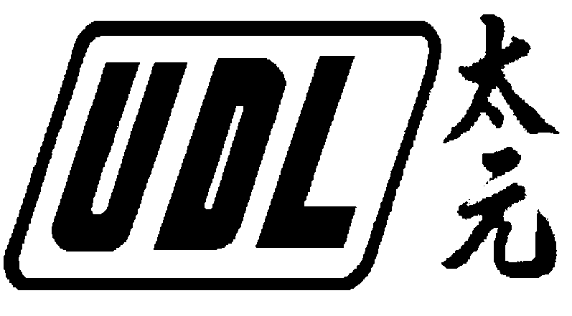 |  |  |  | UDL HOLDINGS LIMITED  (incorporated in Bermuda with limited liability)  (Stock Code: 620)
RESULTS OF ANNUAL GENERAL MEETING
 |  | The Annual General Meeting of UDL Holdings Limited (the “Company”) was held on 28th December 2007 (“AGM”) and all resolutions proposed at the AGM were duly passed by the shareholders of the Company.
 | The board of directors (the “Board”) of the Company is pleased to announce that the following resolutions were passed by the shareholders on a show of hands at the AGM.
1. |  |  | Adoption of the audited consolidated financial statements and the report of the Directors and the auditors for the year ended 31st July 2007;
2. |  |  | Re-elect Mrs. Leung Yu Oi Ling Irene as Director;
3. |  |  | Re-elect Professor Yuen Ming Fai Matthew as Director;
4. |  |  | Re-elect Ms. Tse Mei Ha as Director;
5. |  |  | Authorise the Directors to fix their remuneration;
6. |  |  | Re-appoint CCIF CPA Limited as the Company’s auditors and to authorize the Directors to fix their remuneration;
7. |  |  | Grant a general mandate to the Board for the Company to repurchase the shares of the Company;
8. |  |  | Grant a general mandate to the Board to allot, issue and deal with additional shares of the Company;
9. |  |  | Extend the general mandate granted under resolution No. 8 by adding the shares purchase pursuant to the general mandate granted by resolution No. 7;
10. |  |  | Refresh the limit on grant of options under the Share Option Scheme.
 | Resolutions 1 to 10 were passed as ordinary resolutions at the AGM. Shareholders may refer to the circular dated 29th November 2007 for details of the above resolutions.
 | As at 28th December 2007, the date of the AGM of the company, the total number of shares entitling the holders to attend and vote for or against all the proposed resolutions at the AGM is 5,045,033,739 shares, which is the total issued share capital of the Company. No shareholder was required to vote only against any of the proposed resolutions at the AGM.
By order of the Board
Leung Chi Yin Gillian
Executive Director
 | Hong Kong, 28th December 2007
 | As at the date of this announcement, Mrs. Leung Yu Oi Ling Irene, Ms. Leung Chi Yin Gillian and Mr. Leung Chi Hong Jerry are executive director; Mr. Pao Ping Wing, Professor Yuen Ming Fai Matthew and Ms. Tse Mei Ha are independent non-executive directors.

